THE UNIVERSITY OF AZAD JAMMU & KASHMIR, MUZAFFARABAD


COURSE TITLE | DSA
COURSE CODE | CS-2101
LAB TITLE | ABSTRACT DATA TYPES
STUDENT NAME | HASEEB SHEIKH
STUDENT ROLL NUMBER | 2024-SE-31
INSTRUCTOR NAME | ENGR. SIDRA RAFIQUE
SUBMISSION DATE | OCT 29, 2025

DEPARTMENT OF SOFTWARE ENGINEERING
DSA
Lab 3
Objective
The objective of this lab is to implement a robust C++ Class, BookCatalog, as an Abstract Data Type (ADT). The implementation must use a fixed-size C++ array for storage, demonstrating strong principles of Encapsulation and Abstraction by separating the public interface from the internal data structure.
Abstract Data Types (ADTs)
An Abstract Data Type (ADT) is a logical description of data and the set of operations that can be performed on that data, without specifying how the data is stored or how the operations are executed.
Problem Statement
Implement a BookCatalog ADT. This catalog will store Book records, each containing an ISBN, Title, Author, and Available Copies. The catalog must be built using a native C++ array and must provide the following public methods:
- addBook(Book)
- removeBook(string title)
- searchByTitle(string title)
- displayCatalog()
Code Implementation
The following C++ code implements the BookCatalog ADT using a fixed-size array and includes a main function to demonstrate all public operations.
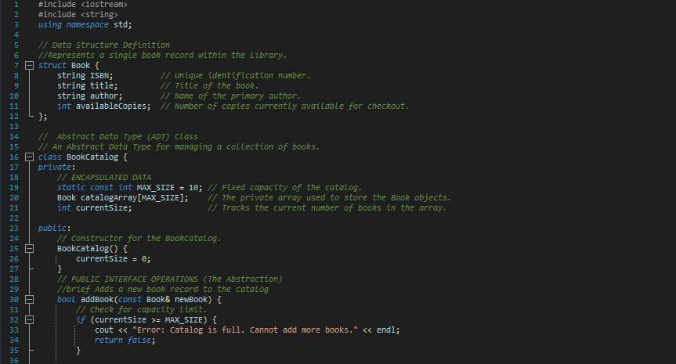

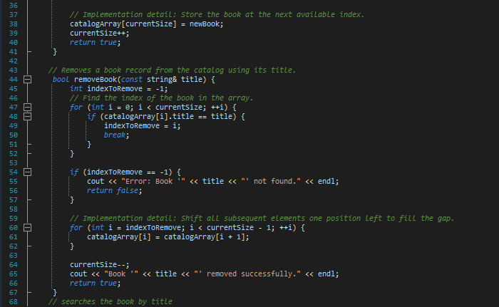
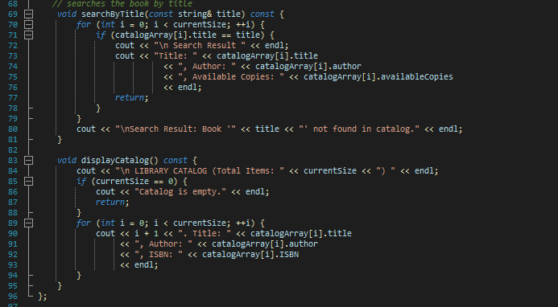

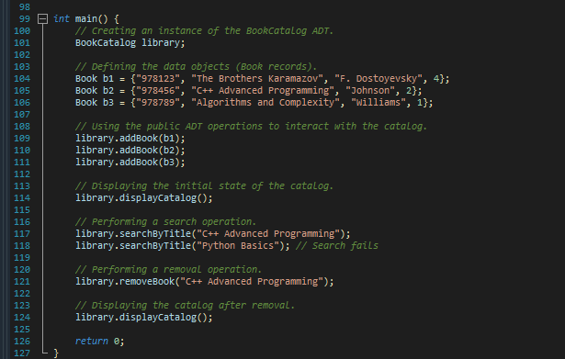

Explanation
- Data Definition and Encapsulation: It defines the Book structure and encapsulates the catalog data within a private fixed-size array (catalogArray) and a size tracker (currentSize) inside the BookCatalog class.
- Abstraction (Public Interface): It exposes a simple set of public methods (addBook, removeBook, searchByTitle, displayCatalog) which allow the user to manage the catalog without seeing the internal array manipulation (like shifting elements).
- Demonstration: The main function creates an instance of the BookCatalog and calls these public methods to demonstrate the complete functionality of the ADT.

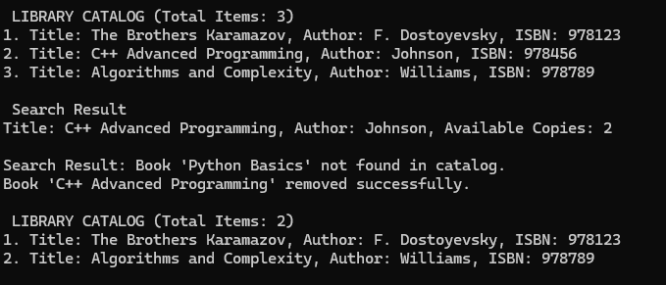
Output

